Chapter 6: Updating Data
Solutions
Answers to Review Questions
1. CREATE TABLE
2. The INSERT command with the VALUES clause.
3. Use the INSERT command with a SELECT clause.
4. UPDATE
5. DELETE
6. COMMIT. In SQL Server, the command is COMMIT TRANSACTION.
7. ROLLBACK. Any updates that have not been committed will be reversed. In SQL Server, the command is ROLLBACK TRANSACTION.
8. Before beginning the updates for a transaction, commit any previous updates by executing the COMMIT command. Complete the updates for the transaction. If any update cannot be completed, execute the ROLLBACK command and discontinue the updates for the current transaction. If you can complete all updates successfully, execute the COMMIT command after completing the final update.
9. The clause is SET followed by the column name, followed by an equals sign (=) and the word NULL.
10. The ALTER TABLE command with the ADD clause.
11. In Oracle, the ALTER TABLE command with the MODIFY clause. In SQL Server, the ALTER TABLE command with the ALTER COLUMN clause.
12. DROP TABLE
13. [Critical Thinking] A make table query is a query that allows you to create a table from another table. CREATE TABLE, SELECT, and INSERT.

Answers to TAL Distributors Exercises
1.
CREATE TABLE NONGAME
(ITEM_NUM CHAR(4) PRIMARY KEY,
DESCRIPTION CHAR(30),
ON_HAND DECIMAL(4,0),
CATEGORY CHAR(3),
PRICE DECIMAL(6,2) );

In Access, the command is:
CREATE TABLE NONGAME
(ITEM_NUM CHAR(4) PRIMARY KEY,
DESCRIPTION CHAR(30),
ON_HAND NUMBER,
CATEGORY CHAR(3),
PRICE CURRENCY );

2.
INSERT INTO NONGAME
SELECT ITEM_NUM, DESCRIPTION, ON_HAND, CATEGORY, PRICE
FROM ITEM
WHERE CATEGORY <> 'GME';

SELECT *
FROM NONGAME;
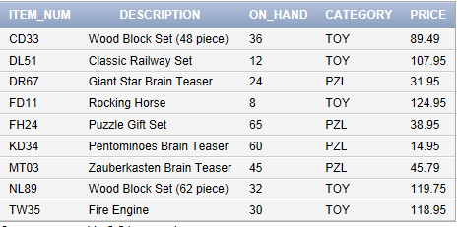

3.
UPDATE NONGAME
SET DESCRIPTION = 'Classic Train Set'
WHERE ITEM_NUM = 'DL51';

SELECT *
FROM NONGAME;
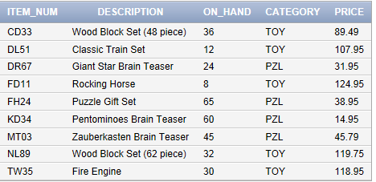

4.
UPDATE NONGAME
SET PRICE = PRICE * 1.02
WHERE CATEGORY = 'TOY';

SELECT *
FROM NONGAME;
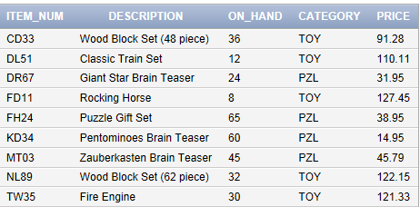

5.
INSERT INTO NONGAME
VALUES
('TL92','Dump Truck',10,'TOY',59.95);

SELECT *
FROM NONGAME;
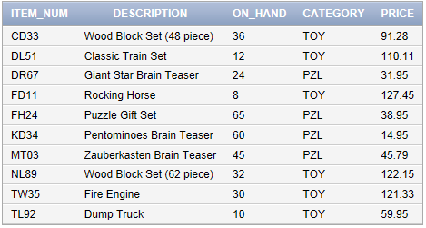

6.
DELETE FROM NONGAME
WHERE CATEGORY = 'PZL';

SELECT *
FROM NONGAME;
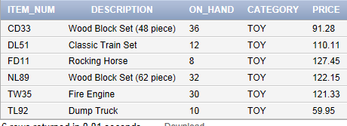

7.
UPDATE NONGAME
SET CATEGORY = NULL
WHERE ITEM_NUM = 'FD11';

SELECT *
FROM NONGAME;
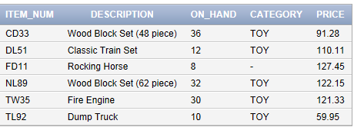

8.
ALTER TABLE NONGAME
ADD ON_HAND_VALUE DECIMAL(7,2);

In Access, use Design view to change the structure of a table.

UPDATE NONGAME
SET ON_HAND_VALUE = ON_HAND * PRICE;

SELECT *
FROM NONGAME;
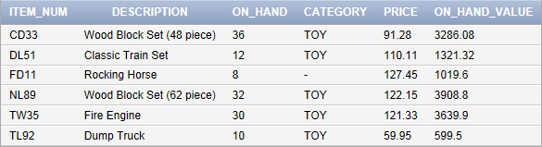

9.
ALTER TABLE NONGAME
MODIFY DESCRIPTION CHAR(40);

In SQL Server, the command is:
ALTER TABLE NONGAME
ALTER COLUMN DESCRIPTION CHAR(40);

In Access, use Design view to change the structure of a table.

To describe the layout and characteristics of the NONGAME table, use the DESCRIBE command in Oracle, the Documenter in Access, and the stored procedure Exec sp_columns in SQL Server.

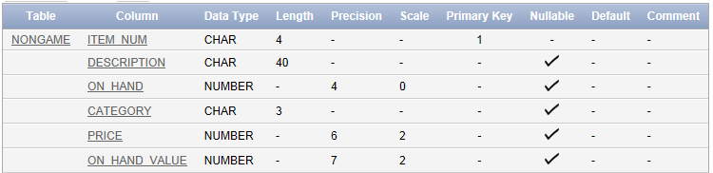
10.
DROP TABLE NONGAME;

11. [Critical Thinking]
ALTER TABLE NONGAME
DROP COLUMN ON_HAND_VALUE;
The command is the same in both Oracle and SQL Server.
Answers to Colonial Adventure Tours Exercises
1. In Oracle and SQL Server the command is:
CREATE TABLE PADDLING
(TRIP_ID DECIMAL(3,0) PRIMARY KEY,
TRIP_NAME CHAR(75),
STATE CHAR(2),
DISTANCE DECIMAL(4,0),
MAX_GRP_SIZE DECIMAL(4,0),
SEASON CHAR(20) );

In Access, the command is:
CREATE TABLE PADDLING
(TRIP_ID NUMBER PRIMARY KEY,
TRIP_NAME CHAR(75),
STATE CHAR(2),
DISTANCE NUMBER,
MAX_GRP_SIZE NUMBER,
SEASON CHAR(20) );

2.
INSERT INTO PADDLING
SELECT TRIP_ID, TRIP_NAME, STATE, DISTANCE, MAX_GRP_SIZE, SEASON
FROM TRIP
WHERE TYPE = 'Paddling';

SELECT *
FROM PADDLING;
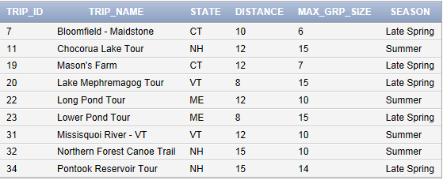

3.
UPDATE PADDLING
SET MAX_GRP_SIZE = MAX_GRP_SIZE + 2
WHERE STATE = 'CT';

SELECT *
FROM PADDLING;
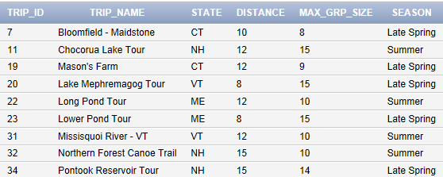

4.
INSERT INTO PADDLING
VALUES
(43,'Lake Champlain Tour','VT',12,16,'Summer');

SELECT *
FROM PADDLING;
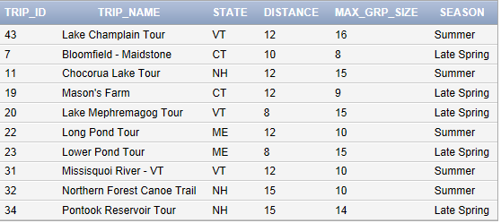

5.
DELETE FROM PADDLING
WHERE TRIP_ID =23;

SELECT *
FROM PADDLING;
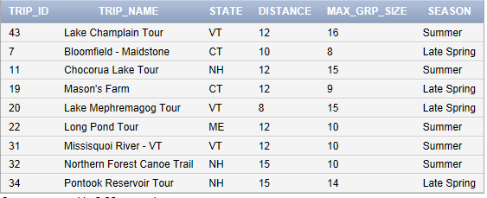

6.
UPDATE PADDLING
SET DISTANCE = NULL
WHERE TRIP_NAME = 'Pontook Reservoir Tour';

SELECT *
FROM PADDLING;
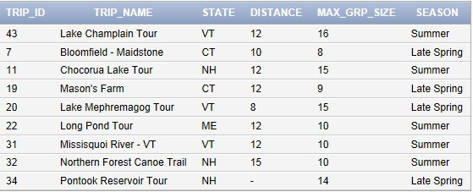

7.
ALTER TABLE PADDLING
ADD DIFFICULTY_LEVEL CHAR(3);

In Access, use Design view to change the structure of a table.

UPDATE PADDLING
SET DIFFICULTY_LEVEL = 'MOD';

SELECT *
FROM PADDLING;
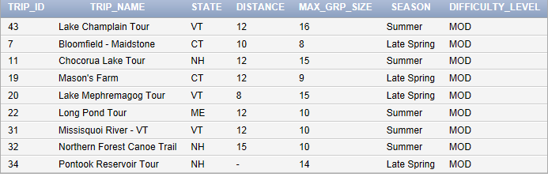

8.
UPDATE PADDLING
SET DIFFICULTY_LEVEL = 'HRD'
WHERE TRIP_NAME = 'Lake Champlain Tour';

SELECT *
FROM PADDLING;
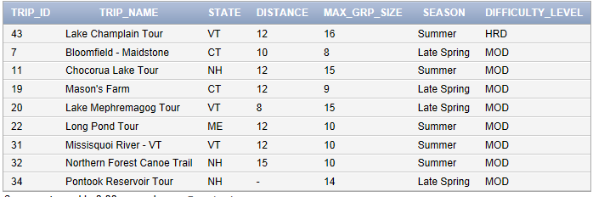

9.
ALTER TABLE PADDLING
MODIFY SEASON CHAR(25);

In SQL Server, the command is:
ALTER TABLE PADDLING
ALTER COLUMN SEASON CHAR(25);

In Access, use Design view to change the structure of a table.

To describe the layout and characteristics of the PADDLING table, use the DESCRIBE command in Oracle, the Documenter in Access, and the stored procedure Exec sp_columns in SQL Server.
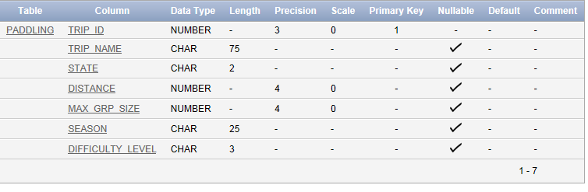
10.
ALTER TABLE PADDLING
MODIFY DIFFICULTY_LEVEL NOT NULL;

In SQL Server, the command is:
ALTER TABLE PADDLING
ALTER COLUMN DIFFICULTY_LEVEL NOT NULL;

In Access, use Design view to change the structure of a table.

To describe the layout and characteristics of the PADDLING table, use the DESCRIBE command in Oracle, the Documenter in Access, and the stored procedure Exec sp_columns in SQL Server.
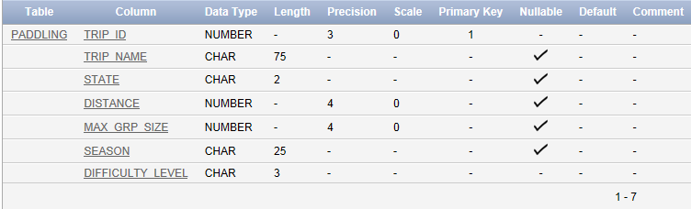

11.
DROP TABLE PADDLING;

12. [Critical Thinking]
CREATE TABLE PADDLING
(TRIP_ID DECIMAL(3,0) PRIMARY KEY,
TRIP_NAME VARCHAR(75),
STATE VARCHAR(2),
DISTANCE DECIMAL(4,0),
MAX_GRP_SIZE DECIMAL(4,0),
SEASON VARCHAR(20) );

Answers to Solmaris Condominium Group Exercises
1.
CREATE TABLE LARGE_CONDO
(LOCATION_NUM DECIMAL(2,0),
UNIT_NUM CHAR(3),
BDRMS DECIMAL(2,0),
BATHS DECIMAL(2,0),
CONDO_FEE DECIMAL(6,2),
OWNER_NUM CHAR(5),
PRIMARY KEY(LOCATION_NUM, UNIT_NUM) );

In Access, the command is:
CREATE TABLE LARGE_CONDO
(LOCATION_NUM NUMBER,
UNIT_NUM CHAR(3),
BDRMS NUMBER,
BATHS NUMBER,
CONDO_FEE CURRENCY,
OWNER_NUM CHAR(5),
PRIMARY KEY(LOCATION_NUM, UNIT_NUM) );

2.
INSERT INTO LARGE_CONDO
SELECT LOCATION_NUM, UNIT_NUM, BDRMS, BATHS, CONDO_FEE, OWNER_NUM
FROM CONDO_UNIT
WHERE SQR_FT > 1500;

SELECT *
FROM LARGE_CONDO;
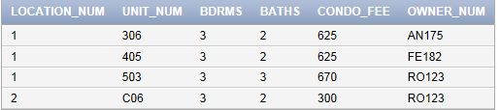

3.
UPDATE LARGE_CONDO
SET CONDO_FEE = CONDO_FEE + 150;

SELECT *
FROM LARGE_CONDO;
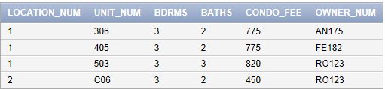

4.
UPDATE LARGE_CONDO
SET CONDO_FEE = CONDO_FEE * .99
WHERE CONDO_FEE > 750;

SELECT *
FROM LARGE_CONDO;
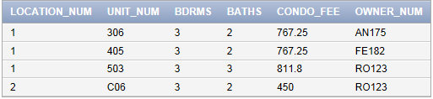

5.
INSERT INTO LARGE_CONDO
VALUES
(1,'605',3,3,775,'FE182');

SELECT *
FROM LARGE_CONDO;
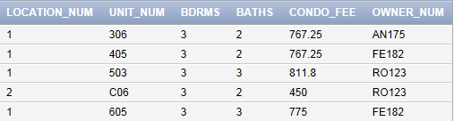

6.
DELETE FROM LARGE_CONDO
WHERE OWNER_NUM = 'AN175';

SELECT *
FROM LARGE_CONDO;
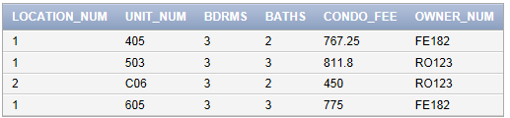

7.
UPDATE LARGE_CONDO
SET BDRMS= NULL
WHERE LOCATION_NUM = 1
AND UNIT_NUM = '503';

SELECT *
FROM LARGE_CONDO;
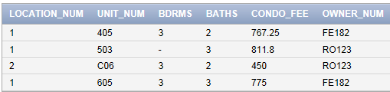

8.
ALTER TABLE LARGE_CONDO
ADD OCCUPIED CHAR(1);

UPDATE LARGE_CONDO
SET OCCUPIED = 'Y';

SELECT *
FROM LARGE_CONDO;
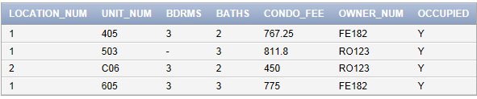

9.
UPDATE LARGE_CONDO
SET OCCUPIED = 'N'
WHERE UNIT_NUM = 'C06';

SELECT *
FROM LARGE_CONDO;
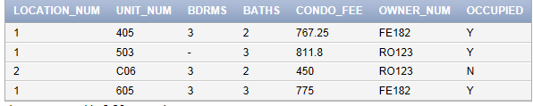

10.
ALTER TABLE LARGE_CONDO
MODIFY CONDO_FEE NOT NULL;

In SQL Server, the command is:
ALTER TABLE LARGE_CONDO
ALTER COLUMN CONDO_FEE DECIMAL(6,2) NOT NULL;

In Access, use Design view to change the structure of a table.

To describe the layout and characteristics of the LARGE_CONDO table, use the DESCRIBE command in Oracle, the Documenter in Access, and the stored procedure Exec sp_columns in SQL Server.
DESCRIBE LARGE_CONDO
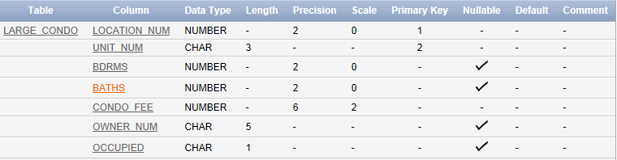

11.
DROP TABLE LARGE_CONDO;

12. [Critical Thinking] Students also could use SMALLINT.
CREATE TABLE LARGE_CONDO
(LOCATION_NUM INTEGER,
UNIT_NUM CHAR(3),
BDRMS INTEGER,
BATHS INTEGER,
CONDO_FEE DECIMAL(6,2),
OWNER_NUM CHAR(5),
PRIMARY KEY(LOCATION_NUM, UNIT_NUM) );

